**IST 722 Assignment 9: Business Intelligence**

* Star Schema after constructing MOLAP(Cube)

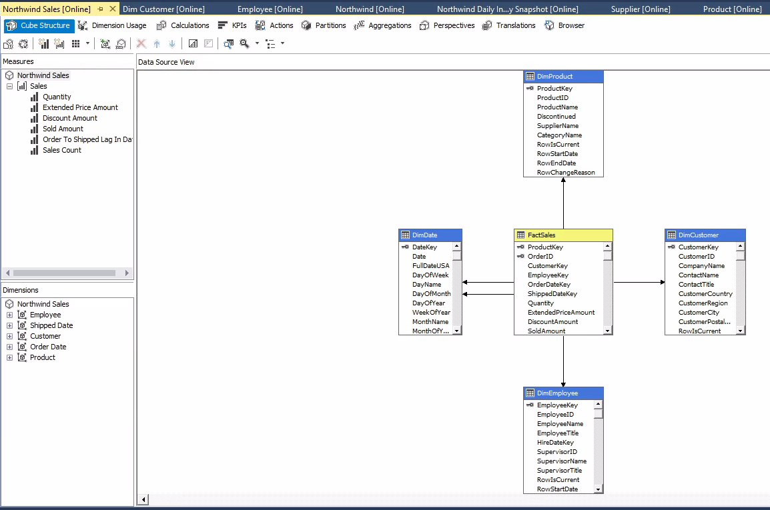

* Excel Pivot Table or Chart output from Step 4A(Getting Data from SQL Server Database)

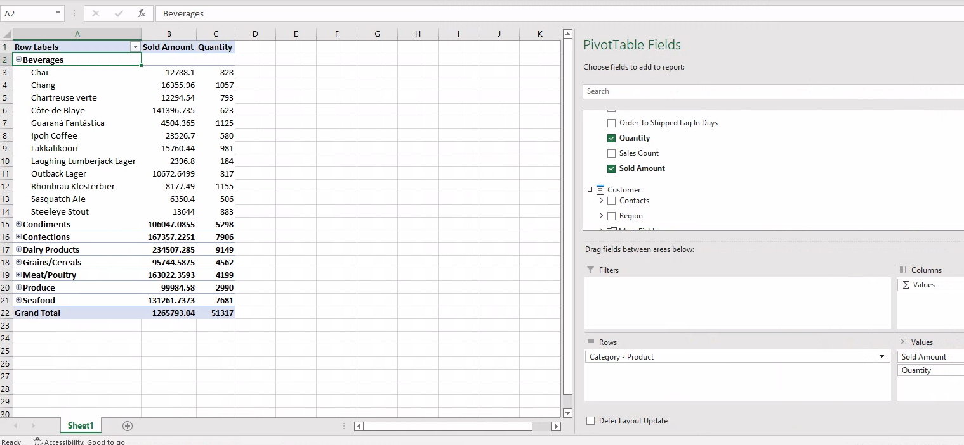

* Excel Pivot Table or Chart output from Step 4A(Getting Data from SQL Server Database)

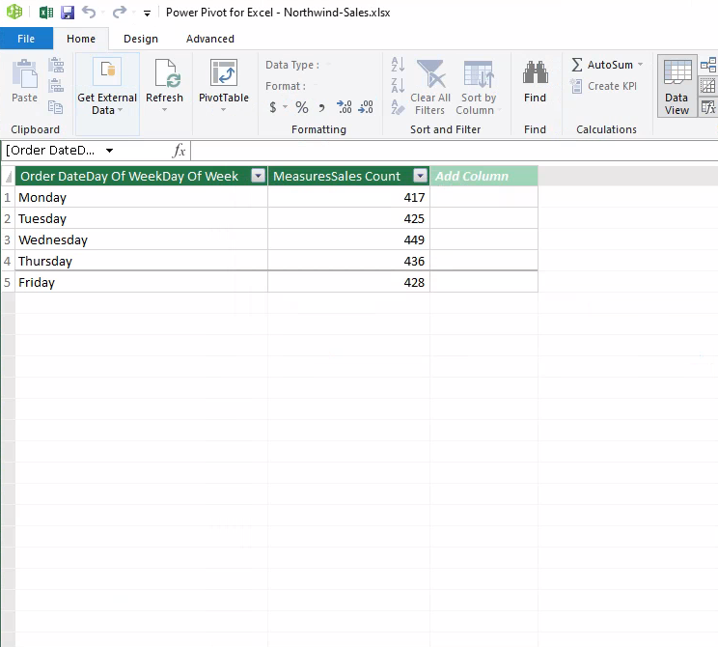

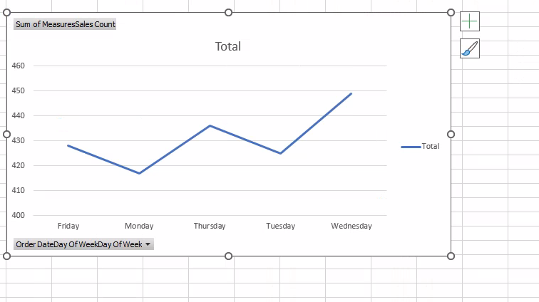

* Power BI Dashboard output from Step 5d(Get Data from SQL Server Database)

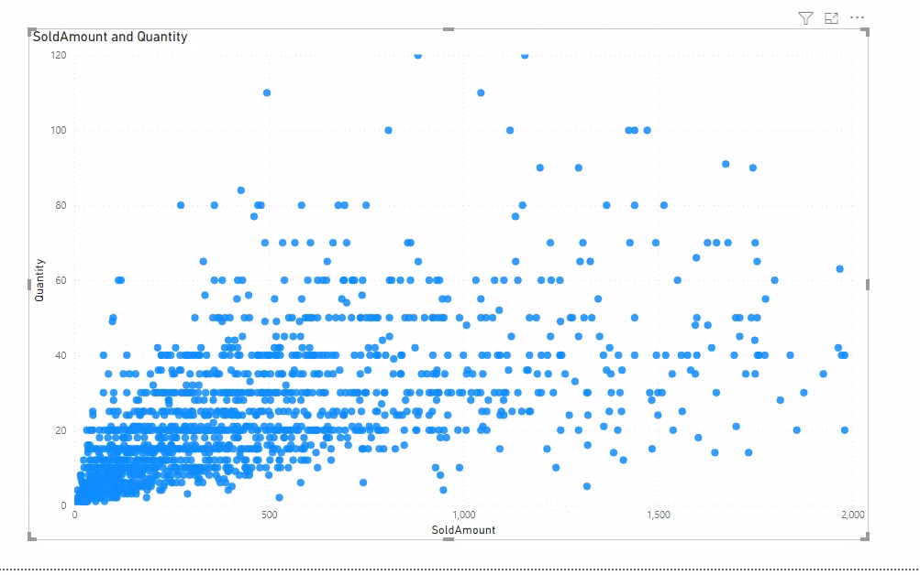

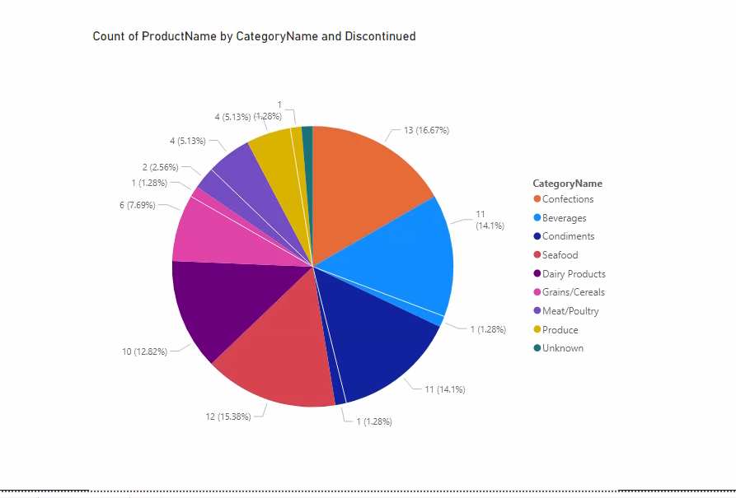

* Power BI Dashboard output from Step 5e(Get Data from Analysis Services)

